Seminar Sheet 7
We are considering data structures and how we can eﬃciently store information. This seminar sheet is aimed at exploring and expanding on your current knowledge. Especially putting to use Maps, Sets and Arrays. In previous worksheets we looked at items, and inventories and recipes and crafting. The aim of this worksheet is to get you to design your own algorithm for a procedural system within a game. Research a simple procedural system from some popular games. This may include, but is not limited to, (simple) maze generation, procedural level generation, procedural spawning of items or weapons or enemies, or more generally procedural placing of assets within a scene. You can choose to implement this seminar sheet in either blueprint, C++ or both. Procedural systems can be very simple or very complex. Consider your design carefully, and be careful not to over scope what you can create in the time frame. Think about the potential pitfalls, and make sure to thoroughly test your system. Think about how designers might be able to tweak and play with your procedural system. Can they add additional meshes to an array to change the types of objects that can spawn at diﬀerent points. If you’re placing meshes or assets consider how you might want to add random variation when placed in the scene? Can you generate rotations and oﬀsets to give the spawned items variation, how can a designer play with these parameters through the details panel?

Problem 1.
  - Research and design a simple procedural game system. Draw upon ideas from games you have played or enjoyed. Consider how the system operates, and what the code requirements might be.
My basic goto idea is looking at Minecraft and, this style isn’t what I want to try and mimic but more towards Cubeworld, a Voxel Based Minecraft with more focus on fighting and exploration, with dungeons and other various zones to survive in.
Cube operates a procedurally generate environment to make a nice and expansive world. I think this is a good way to attempt procedural generation by making worlds designed around blocks and building the world up with terrain and different levels
The code should require something of the sort of chunk generation that is commonly known in Minecraft with iteration over the initial creation of an environment to create smooth terrains.
I don’t want to over complicate this attempt however, I’m not looking at making biomes or cliffs or specific terrain features, and I just want to try at a basic attempt of creating a simple environment. It doesn’t really even have to make sense

Problem 2.
  - Design the UML and consider the information you will need to store to represent the parameters and options your system may have. What are you generating or spawning. How can it be extended by designers or react to sets of assets provided
For assets I will use Kenney’s with block like assets that can be pieces together, using this tile based system in 3D to create procedurally generated terrain. There is some basic nature blocks that should allow me to play with simple placement of a single block type.
My first look at this I didn’t really know much of what I need to have this, the data I need would be the dimensions of the space I would be building in.
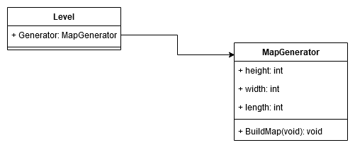
Then I considered a couple rules with block placement as well as how should each “block” represent itself and the data is should also carry.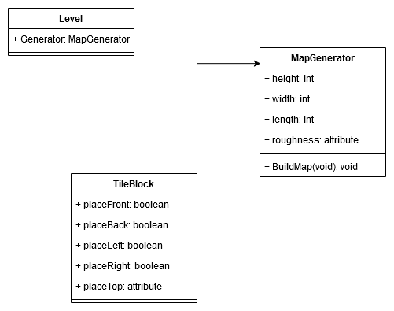
So a tile block could show if the tile is a sort of “end point” or could also work with carrying on the landscape, how I’m going to implement I’m not too sure. Some sort of map to keep track of all tiles.

Problem 3.
  - Implement your UML diagram in either blueprint, C++ or both and create a procedural system
I’m doing this all in Blueprint.
The first to this task I thought rather than making a separate object for the map generator to add all this data into the gamemode, since this would sit ontop of the game and I would only be testing on the one level.
In the gamemode I created the generate map and the variables
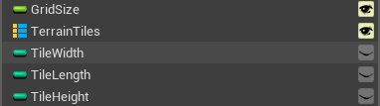
I also added the map that would contain the assets (already imported) using a vector as a key to store each tile based on their location, a grid size is here to make sure it all stays in place and aligned, the gridspace would be dependant on the size of each tile.
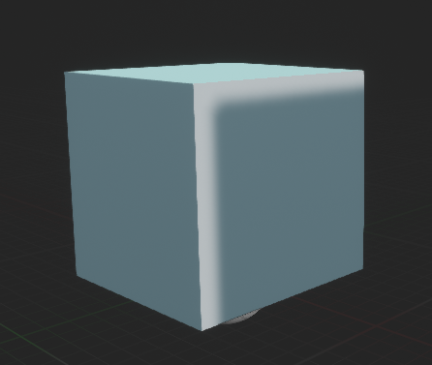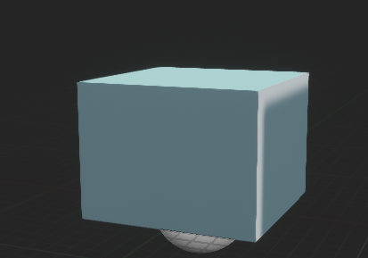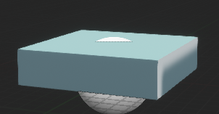
The tiles I’m using are a full block, half height and quarter height which I then just have a child of a base tile.
Using the UML model I designed previous the parent is a base containing the data.
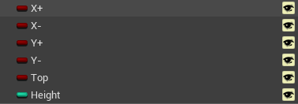
I also added a height variable, to display the height of each tile out of 4
Full – 4
Half – 2
Quarter – 1
There is no main reason right now but it might be worth catching relavent data, as it could be useful when looking of the generation.
Moving from here its time to try placing block, my first is to make a 2d flat plane of full sized blocks, just to be able to make sure being able to place blocks will work fine.
As I’m going through the functions I wanted to just make a flat layer and not a map of sorts I made a flatlayer function
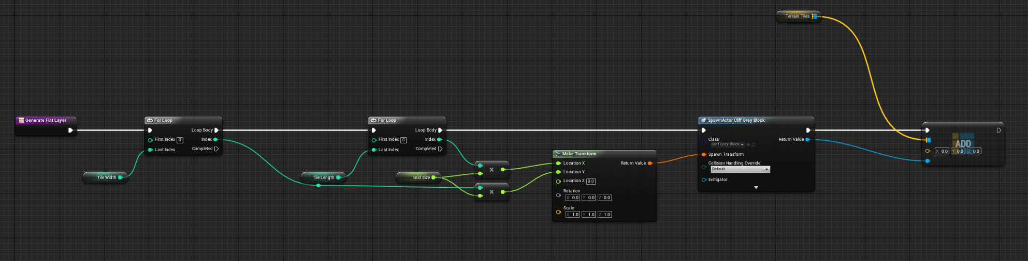
This goes through the two for loops, and places on x and y plane
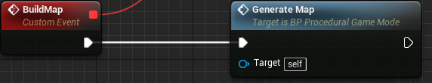
A generate map function which for now will call the flat layer function
This should allow me to better modify segments of the code without touching too many places for when I may want to change how I generate the map.
My test frame is 100 x 100, the height will not be used right now
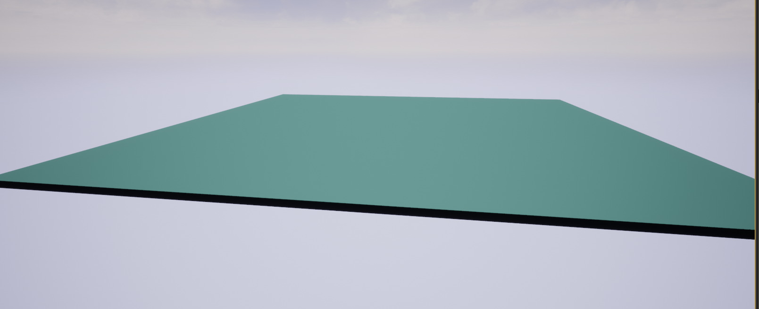
This is 100 x 100 of full height blocks, so this shows I’m on the right track, now I want to start layering but before, when I run the function it give some initial lag, then all blocks suddenly appear, so what I want to do is make the blocks appear in run-time. This is complicated to try in blueprint but I’ve got a whacky solution in mind.
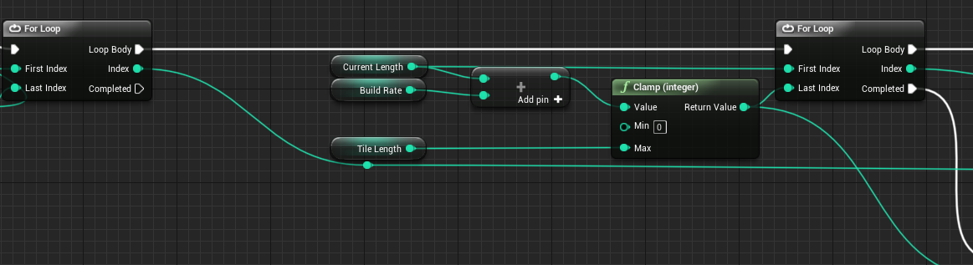
Some changes I need to do is make a build rate (how many times a function call should a block be spawned) and also a variable to keep track of the current position of both the width and length.
Planning ahead I also added a current height
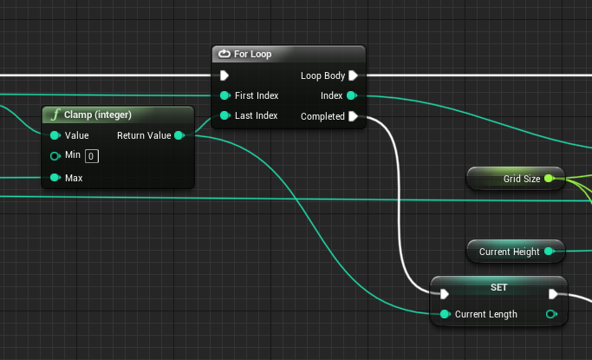
At the end of each loop the current length is update to that of the last index of the for loop, the issue with running as an increment of the for loop is that it end up breaking, the for loops checks the variables each iteration and if iterate them within the loop, the last index goes up with it causing it to show some issues
Finally looking into other areas, as the function compltee for loops this doesn’t mean the layer is completed so I need to make a check
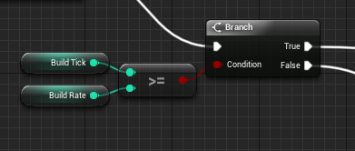
Adding a build tick that increments after the spawning of each tile and then checking if its supparsed the rate check means I know if a row is completed it its met the build rate.
If it hasn’t met the build rate but completed a row then I reset the row manually, as the current length variable is how I keep track inbetween function calls, I also increment the with.
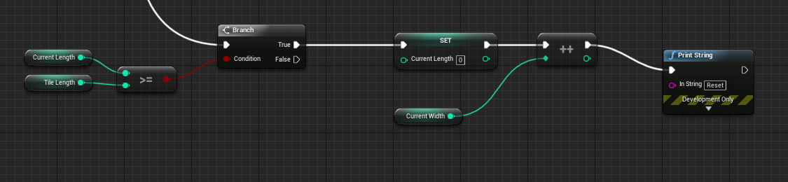
If the build rate is met I make a check I do an aditional check to see if both the length and width (row and column) are completed on a layer, if not I just end the function otherwise I made a reset layer function.
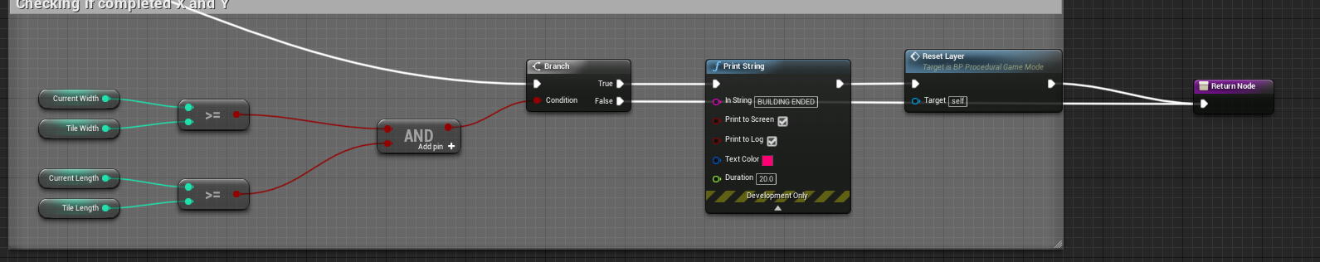
This function sets the width and length current to 0 and increments the height for use in the future. Its like hitting new line on a type writer as I picture it but it is what I need to produce similar on the next height up
